Final Project Report
Xu Ruijing U2501090

1.Problem Definition
Heart sound (phonocardiogram, PCG) analysis plays a significant role in cardiac screening.
The objective of this project is to classify segments of heart sounds into five categories:
Normal | Murmur | Extrahls | Extrastole | Artifact
This is a multi-class classification problem, where the input is an acoustic signal and the output is one of the above five categories.

2.Connection to Class Material
This project is based primarily on two models taught in this course: PCA and SVM. Both models are directly applied to classify log-mel spectral features extracted from the audio.
- Principal Component Analysis (PCA): Used for linear dimensionality reduction and subspace projection.
- Support Vector Machines (SVM): A maximum-margin classifier suitable for high-dimensional data.
In addition, two deep learning architectures (CNN and Transformer) are extensions

3.Dataset Description
The dataset contains 832 labeled PCG recordings from the PhysioNet heart sound dataset (set_a and set_b).Each audio file is sampled and filtered, then segmented into 2-second windows.

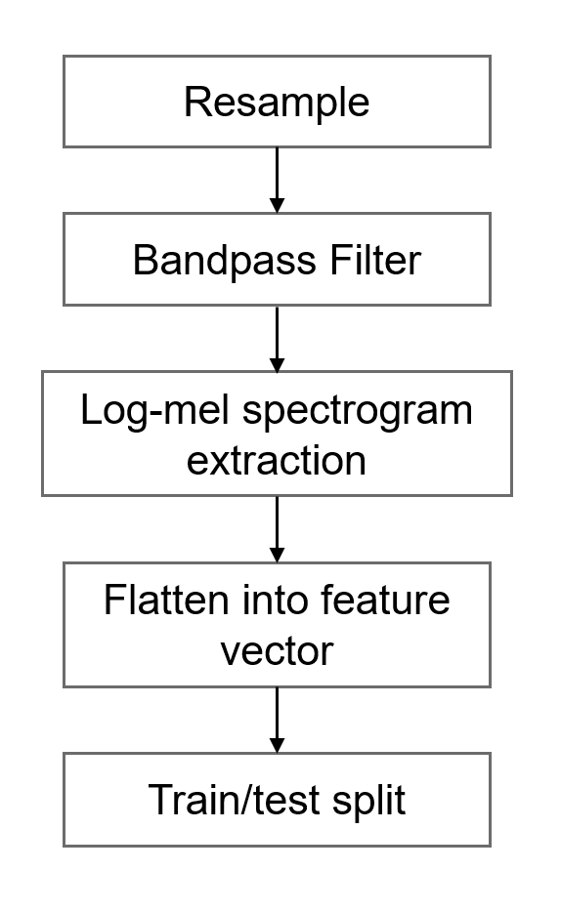 | - Resampling to 4000 Hz
 | - Bandpass filtering between 20–400 Hz
 | - Log-mel spectrogram extraction (64 × 64)
 | - Flattening into a 4096-dimensional feature vector
 | - Train/test split = 80% / 20%, stratified by class

4.Methods
4.1 PCA + SVM (Primary ML Model)
Log-mel spectral vectors (4096-D) are projected into a 50-dimensional PCA subspace, preserving most global variance while reducing redundancy.
An RBF-kernel SVM is trained in the PCA space:
$$k(x_{i},x_{j})=exp⁡(-γ{\left\|\left.x_{i}-x_{j}\right\|\right.}^{2}).$$
Parameter:
- PCA components = 50
- C = 1.0
- γ = “scale”
4.2 Lightweight CNN
A simple 2-D convolutional network processes the 64×64 log-mel input:
- Conv → 3 * Depthwise Separable Conv → Global Avg Pool → Full Connected → Softmax
CNNs can directly learn local time-frequency patterns, which PCA cannot capture.
4.3 Transformer
A compact Transformer encoder treats each mel-frequency bin as a token sequence:
- Patch embedding
- Multi-head self-attention
- Feed-forward transformer blocks
- Linear classifier
Transformers model long-range temporal dependencies and show strong generalization on sequential audio signals.

5.Experimental Results
PCA + SVM | Lightweight CNN | Transformer
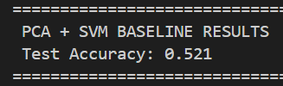 | 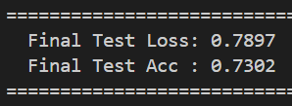 | 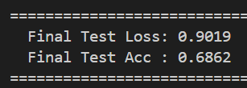

Analysis:
Why does PCA + SVM perform poorly?
- Heart sounds contain complex sequential patterns (S1/S2 cycles, murmurs).PCA performs a linear projection and cannot preserve such non-linear structures.
- Although SVM is powerful, flattening destroys locality, making classification challenging.
Why do CNN and Transformer perform better?
- CNN learns localized patterns such as onset energy and frequency bands of murmurs.
- Transformer captures long-range temporal dependencies across frames.

Parameters tuning:
PCA: n_components：[20, 50, 100]
SVM: C：[0.1, 1.0, 10.0], gamma：["scale", 0.01, 0.001]
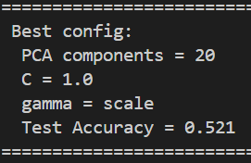
As for lightweight CNN and Transformer, we briefly tuned learning rate and weight decay but found only marginal improvements

6.Insights
- Classical ML is limited for structured acoustic signals.PCA fails to encode temporal dynamics essential for heart sound discrimination.
- Deep models excel because they learn hierarchical features. CNNs learn local patterns while Transformers learn global ones.
- Even DL accuracy peaks around 0.75–0.80 due to label noise and inconsistent heartbeat cycles.

